
Department of Mechanical Engineering

EMCH 368
MECHATRONICS

Lab 10
PID Controller

Last Edited: 10/23/2024 by T. Sucin

Simulink is a program within MATLAB that features a graphical programming environment developed by MathWorks. It is used for modeling, simulating, and analyzing multi domain dynamical systems using block libraries which we will explore. Refer to the Appendix for information on the blocks used in this lab.

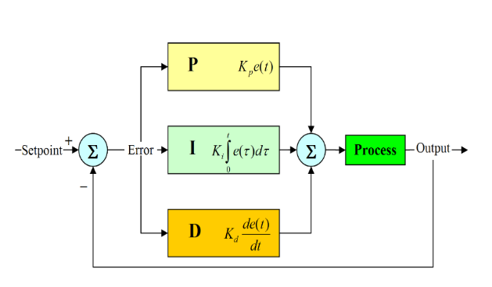
PID controllers are a type of feedback controller used to drive a process variable to a desired setpoint using three parts. PID controllers are widely used thanks to their simplicity and robustness.
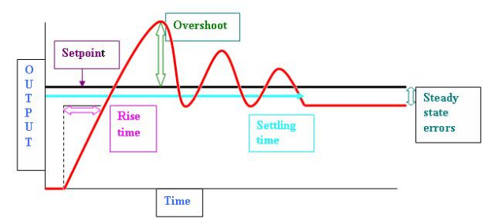
PID Terminology [4]

PID Basics
PID controllers use the output of a process (also called a plant) to provide control inputs to drive the plant to a specified setpoint. This is calculated as the sum of three parts as shown in the equation below. The Proportional part generates a control input that scales with the difference between the setpoint and output (referred to as error). This usually does a lot of the work, but it can cause the system to overshoot the setpoint is prone to producing steady state errors that persist over time. The integral term generates input based on the presence of error over time to drive down any steady state error. However, a large integral term can cause large oscillations and very large control inputs if error is allowed to integrate. Finally, the derivative term generates input based on the instantaneous rate of change of the error to dampen larger inputs. Because inputs such as noise have large derivatives, a large derivative gain can inadvertently cause oscillation.
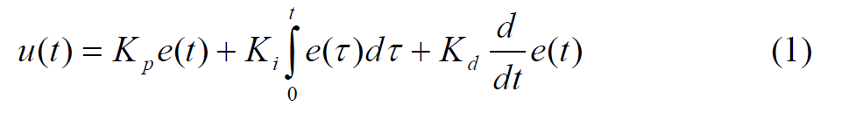

Accessing the Simulink / Arduino interface
Simulink can be used in conjunction with Arduino to collect data and issue commands accordingly. The goal of this lab is to create a control circuit using an Arduino to issue commands to Simulink, which is then used to tune the gains of a PID controller.
With MATLAB open, click the Simulink tab to open Simulink. In the menu that pops up, click “Blank Model” to open a new model.
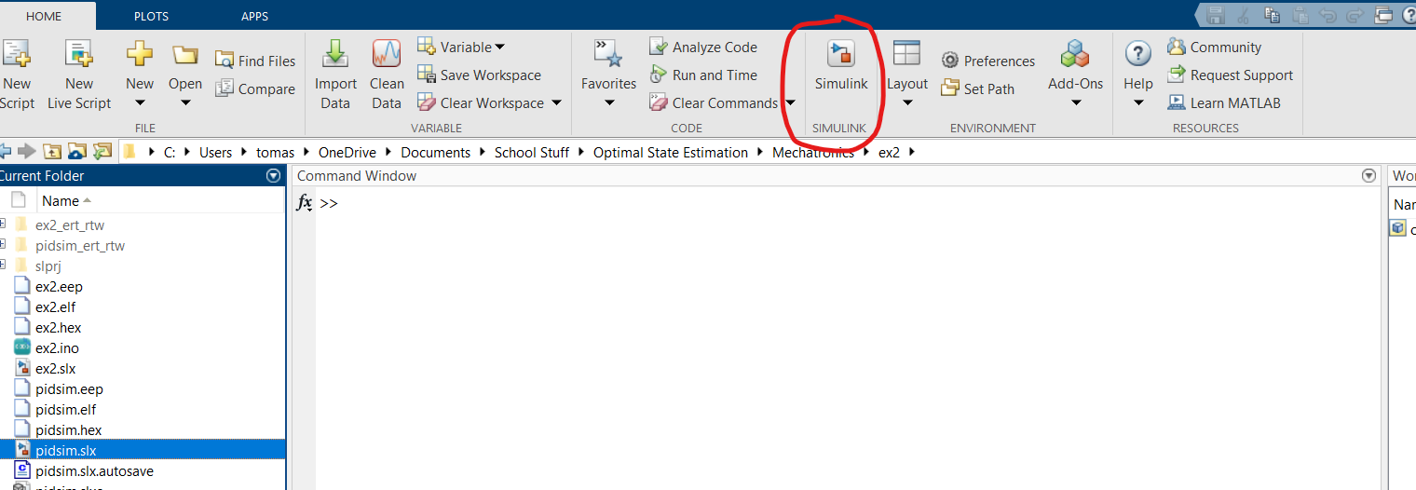
Under the “Apps” tab, click “Get Add-Ons” to access the add-ons store. Search for “Simulink Support Package for Arduino” and install it. Refer to the extra resources at the end of the document for help.

Assignments
This lab contains three exercises:
- Exercise 1 – Simulink Basics
- Exercise 2 – Tuning with Arduino
- Exercise 3 - PID controller
For grading purposes, you will present the scopes from the different exercises in-person during your specified lab session.

Exercise 1 – Simulink Basics
This exercise covers some of the basics of building systems in Simulink. The goal is to create a system that takes constant input and operates with it to produce an output with a way to visualize the behavior of the system.

- To add blocks to the system, search in the library browser tab and drag blocks onto the workspace or double-click the workspace and search for the blocks you want to use.
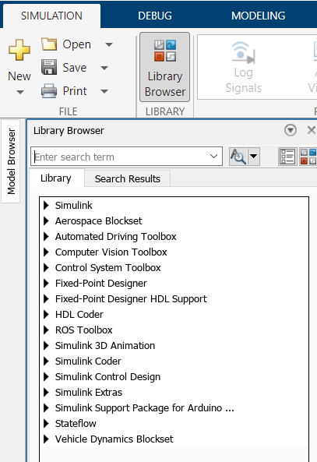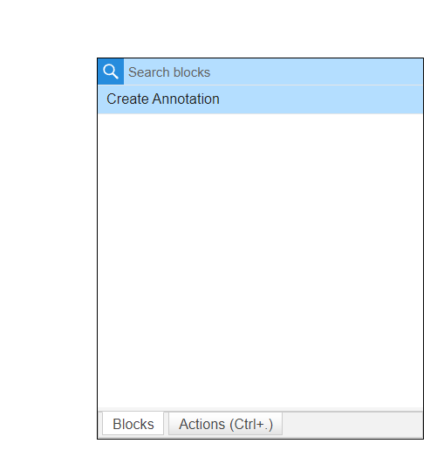
The library browser and workspace search menu

- Add a Constant block for the input. Double click it to change its settings and change the value to a number of your choosing.
  - Clicking the block allows you to change the size of the block
  - Hovering over the three dots above the block after clicking opens some useful features such as displaying the block name and commenting out the block
- Next, add a Gain block to scale the input. Click the output of the Constant and then click the input of the Gain to connect the two.
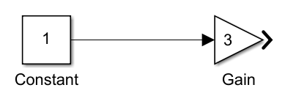
Connected blocks

- Next, add a Sum block and another Constant. Connect the output of the gain and the new Constant to the inputs of the Sum. The output is the sum of the two inputs.
- At the output of the Sum, add a Scope. Like the serial monitor in Arduino, this is a helpful tool for seeing outputs and can be used for visualization, debugging, and more.
  - Double clicking the Scope with pull up the graph.
  - Alternatively, you can insert a Dashboard Scope which will show the graph on the board you're working on instead of in a new tab.

- Finally, click and drag the screen to select the blocks between the input Constant and the Scope. Hover over the three dots next to the selection box and click “create subsystem.” This combines the two operations of our system into one block.
  - Although our system is simple, the subsystem feature improves organization on more complex systems
  - The Subsystem block can also be used to create subsystems
  - Double clicking the subsystem opens its workspace and allows you to modify it
- To test the system, click “Run” at the top of the screen and double click the Scope to see the output.
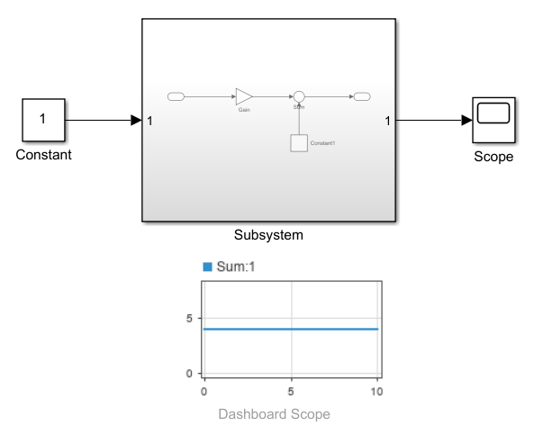
The completed exercise 1 system. Note the subsystem showing its internal connections.
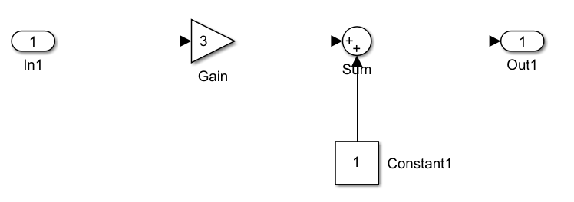
The exercise 1 subsystem
Exercise 2 - Tuning with Arduino
- In this exercise, we will explore using Arduino to interact with Simulink. The objective is to use a single potentiometer to tune three different gains that will be later be used in a PID controller.
- The model and blocks will be more advanced, but building the model is still a straightforward process
The Circuit
- The circuit for this exercise is simple, only requiring three components
- Connect a potentiometer to an analog pin
2. Connect a button and an LED to two digital pins (The LED will be used in the next exercise).
Simulink: Setup
- Create a new blank model and under the “Apps” tab, click “Run on Hardware” and select the Uno board. To finish setting up the simulation, open the model settings under the “Modeling” tab and apply the following settings:
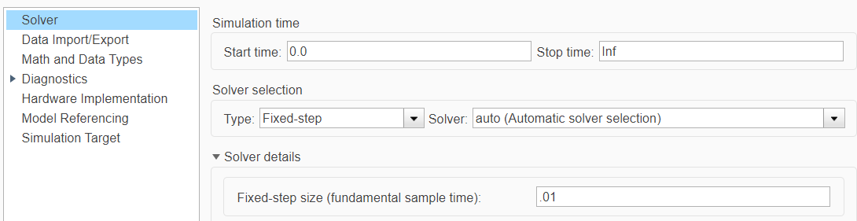

  - This sets the sample time as well as allowing the model to run until it is stopped manually.

- Add the Digital Input and Analog Input blocks from the Arduino Support library. These will read inputs from the circuit. Ensure the pins on the blocks match the circuit.
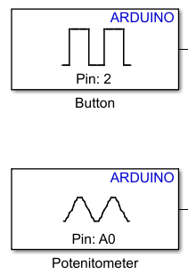
Arduino Input Blocks
Simulink: Digital Input (Button)
- Add the Detect Rise Positive block and connect it to the output of the Digital Input. This detects when the button is pressed and outputs a 1.
- Next, add the Discrete-Time Integrator to the output of the Detect Rise Positive. This is used to track the number of button presses by integrating the signals it recieves with each press.
  - In the settings for this block, change the output data type to “Double”
- Multiply the Integrator output by 10 and feed it into a Mod block. Add a constant block with a value of 3 to the other Mod input. The Mod block works like the % operator in Arduino, returning the remainder of a division of two numbers. Since we have three gains to tune, we can use the values 0, 1, and 2 (the outputs of the Mod) to index our gains. The order of inputs to the Mod block matters, so make sure to check which port to use for the integrator and constant.
Simulink: Switch Subsystem
- Add a Subsystem block and double click it to work inside it. Delete the wire between the Input and Output that already exists. A subsystem is used here to declutter the workspace and avoid crossing wires.
- In addition to the blocks already in the subsystem, add an Input block to create a port for the subsystem to connect to.
- To change the first gain (index 0), we want to check the Mod output to see if it is 0. To do this, connect one of the Inputs and a 0 Constant to the Relational Operator. Make sure the Relational operator is set to = =. If the Mod is 0, this block will output a 1 (true).
- Connect this to the top input of an Enabled Subsystem (ES) block. This block will only activate if it receives a 1 in this port and is the key to switching which gain is being tuned.
- Connect the other subsystem input to the input of the ES and connect the ES’s output to the subsystem’s outputs.
  - Between the ES output and the subsystem output, add a gain. This is used to scale the potentiometer’s output to reasonable gain values for the controller in exercise 3. Change the value for this gain to 0.2
- Repeat this process for two more gains (indexed 1 and 2). Although you will need to add an Input and Output to the subsystem for each Gain respectively, you can use the same Input for all 3 ES blocks. Change the scaling Gain for these two to 0.0001 and 0.02 respectively.
  - Naming the blocks here will help you keep track of the different inputs and outputs
  - In total, the subsystem should have 3 inputs for the Mod block to feed into, an input for the potentiometer, and 3 outputs for the gains.
Simulink: Connecting it All and Testing
- Connect the output of the Analog Input to the switch subsystem
- Connect the Mod output into each mod port of the switch subsystem
- For visualization purposes add a scope and create three inputs using the File tab and View tab > Layout as shown:
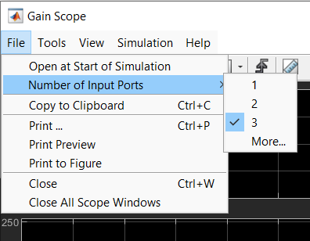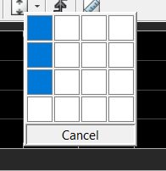
- Connect the Subsystem outputs to this Scope
- To test the model. Click “Monitor and Tune” under the “Hardware” tab.
  - Note: If you get an error related to board memory, try setting the hardware to a different board, running the model, then switching back to the Uno when it fails.
- Once the model compiles and starts running, open the Scope and look at the different gains
  - Use Tools > Axes Scaling > Automatic Scaling to keep the axes in range
- Use the button to switch which gain is being tuned and use the potentiometer to set the value.

Exercise 3 - PID Controller
- Putting everything together, we will now use our gains from exercise 2 to run a PID controller. We’ll also add an LED to show us when the output is within an acceptable range to the setpoint. Refer to the diagram in the introduction for a general PID controller schematic.
- Simulink has a built in PID block. Add one next to the gains we made in exercise 2. Change the source setting to external. This lets us provide external input for the gains.
- Connect a constant of 100 to the N port on the PID block.
- Connect the Kp, Ki, and Kd gains from the switch subsystem to the P, I, and D ports of the PID block. Keep a scope connected to these gains. This will be used for testing.
- To establish our setpoint, use a Step Function with amplitude 30. Change the step time to 32s, this will also be used for testing. Connect it to one input of a Sum in front of the PID block. Change the other sum input to a minus sign to take the difference.
- At the output of the PID, add a Transfer Function, change the coefficients to produce the function:
$$H\left(s\right)=\frac{s+3}{s^{2}+2s}$$
- Take the output of the Transfer Function and wire it to a Scope. This will let us see the controller’s response. Also wire the output to the minus port of the Sum from earlier. Feed the difference into the last input of the PID block
- The controller is now complete. The last thing to add is some logic to light up the LED if the system reaches its setpoint. Using the system’s output, create a set of blocks that outputs to a Digital Output block if the system is within 0.1 of its 30 setpoint.
  - Hint: Simulink includes logic gates and relational operators that can be used to form something similar to an if statement in Arduino.
Using the System
- Open the Scopes connected to the gains and the system output. This lets us see these values in real time.
- Click the “Monitor and Tune” button at the top, this will start running the system.
  - Depending on your computer this may take around a minute to compile. You can see when the system starts running by looking for the time in the bottom of the screen
- Since the Step Function does not activate until 32 seconds, you will have this much time to tune the gains before seeing how the controller responds.
- Use the potentiometer to tune the selected gain, by default this will start with Kp. After tuning Kp, press the button to switch to Ki, then repeat for Kd. If 32 seconds is not enough time, change the Step Function time to give yourself more time to tune.
- After the Step Function activates, observe the system response. Give the system a few seconds and then stop the simulation to analyze the data.
  - Does the output settle at 30 and turn the LED on?
  - Does the system oscillate before settling?
  - Does the system diverge uncontrollably?
  - How much time does it take to converge?
- Try to find an optimal set of gain values that minimizes oscillation and instability while quickly settling to 30.
- When you are done, present the output Scope and the lit-up LED to the TAs.

- Use the table below to guide you through the tuning process.
Parameters | Rise-time | Overshoot | Settling time | Steady state  error | Stability
Kp | Decrease | Increases | Small change | Decrease | Increase
Ki | Decrease | Increases | Increases | Eliminates | Increase
Kd | Small change | Decrease | Decrease | No effect | Decrease

Notes:
- Based on the scaling gains in the switch subsystem, the values for Kp, Ki, and Kd max out at 200, 0.1, and 2 respectively. These ranges provide reasonable values to experiment with.

- How to use the Table for tuning:
For example, here overshoot is high, you need to decrease it so look at the table under Overshoot: Decrease, along the horizontal it points to Parameter Kd. So, adjust Kd gain repeat the process till you get a satisfactory value.
- When tuning PID, start small and climb your way up in gain, start by proportional, integration, and finally the derivative gain as it’s the one with the most instability.

- Consider adjusting the sampling rates of analog read, scope, simulation for a clear waveform.

- Try using the display settings of your scope to make your graph lines thicker and different colors.

Lab 10 Grading Rubric:
- Exercise 1 (Simulink Basics) complete with accurate scope (5 points)
- Exercise 2 (Arduino Tuning) complete with accurate scope (15 points)
- Exercise 3 (PID Controller) complete with accurate scope (20 points)
- Comprehension Questions (10 points)
(Total 50 points)

Extra Resources

- https://www.mathworks.com/hardware-support/arduino-simulink.html
- https://www.mathworks.com/videos/programming-arduino-uno-with-simulink-86316.html
- https://www.youtube.com/watch?v=nOz3uTi20Jo
- https://medium.com/autonomous-robotics/pid-control-85596db59f35

Appendix: Simulink Blocks
- Constant: used to input constants into simulation.
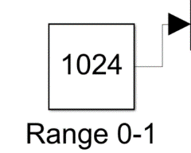
- Derivative: Gives the derivative of an input with respect to time.
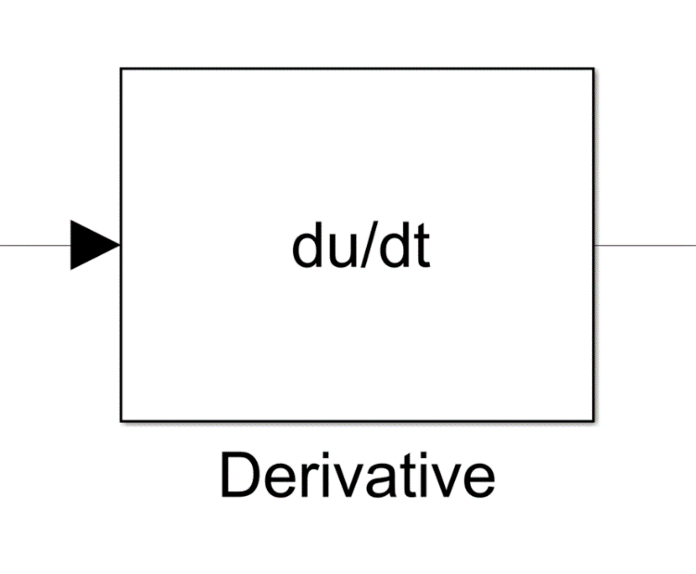
- Integrator: Integrates a given input over time.
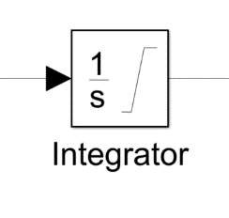
- Product: Multiplies two given inputs.
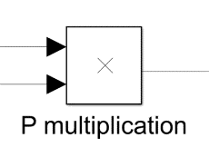
- Divide: Divides a given input 1 by input 2.
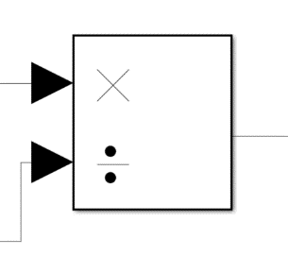
- Sum: Used to add or subtract two or more inputs.
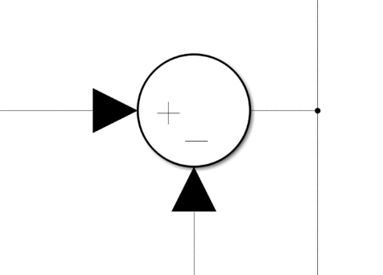
- Mod: Returns the remainder of input 1 divided by input 2
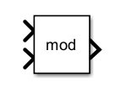
- Relational Operator: Compares two values.
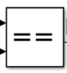
- Display: Indicates input numerically
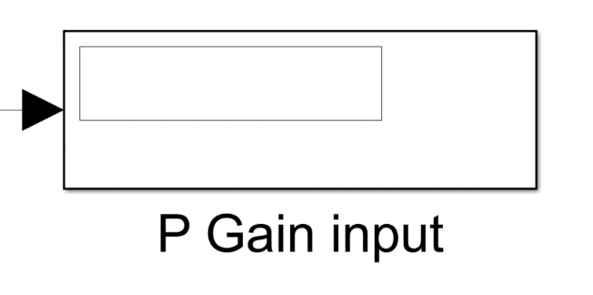
- Scope: Indicates inputs graphically.
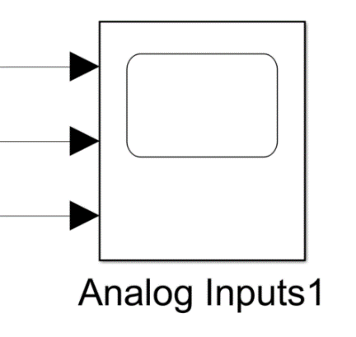

- Transfer Function: Operates on an input to produce an output, represents real plant.
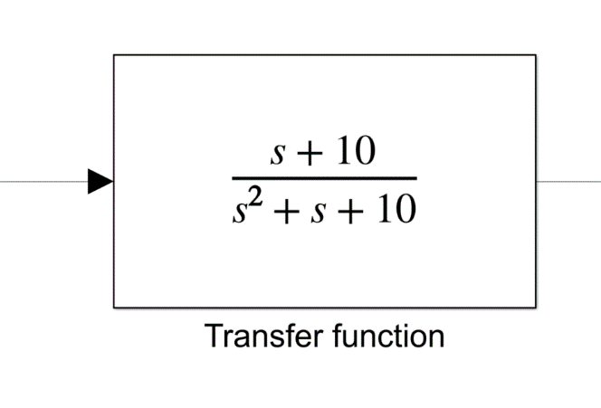
- Step: Produces a step function.
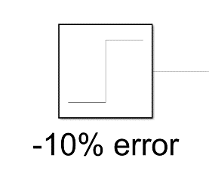
- Detect Rise Positive: Detects increase of value if previous value is not positive.
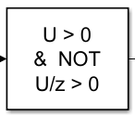
- Enabled Subsystem: Allows for a system to be triggered by a defined input.
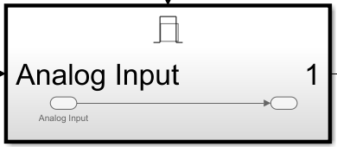
- Discrete-Time Integrator: Integrates inputs over time.
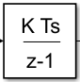
- Digital Input: Reads a digital input from Arduino
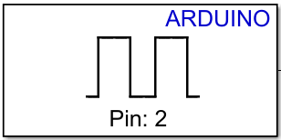
- Analog Input: Reads an analog input from Arduino
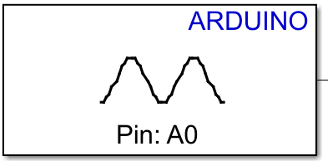
- Digital Output Sends a digital output to Arduino
